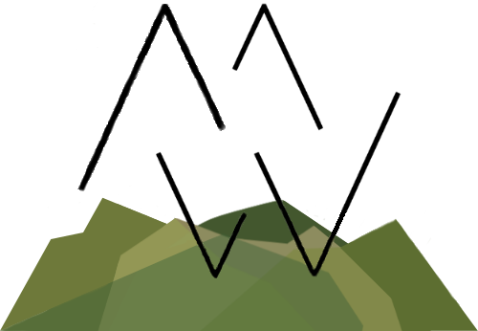

Ready to join the MW team and create a new chapter or join your current chapter’s trail leads? We’re so excited to get to know you and have you on board. We take our responsibility to our military community VERY seriously, which means that we hold ourselves our ambassador program to very high standards.
While it's a volunteer position, our ambassador program requires passion and ownership within your community, and we'll expect a high level of responsibility and motivation. Whether you're a weekend warrior who hikes on their days off, or a "full time" adventurer, we know that with heart and drive you can be an awesome force in our community.
So how does it work?

Interview Process
First, you’ll go through the interview process. This is where we’ll meet you, get to know you, and talk about all the fun ideas you have for helping your local military community get outside. Typical Ambassador onboarding consists of:
- Ambassador application (this!)
- Video interview submission, and if accepted…
- Training pipeline (opening your chapter, learning the ropes, and regular check-ins with your mentor for the first three months)
Our training pipeline is designed to walk new ambassadors through each aspect of our program, teach our methods for community outreach, develop a strong and open line of communication between Ambassadors and the Board of Directors, and ensure that we’re each a good fit for one another.

Ambassador Responsibilities
As an MW Ambassador, you’ll be expected to represent our organization and military community in a professional and positive manner. While we want to leave lots of room for your creativity in growing your chapter and getting your community outside, there are certain responsibilities and structures put in place to make sure that we’re serving each community as best we can.
One of the great aspects of our ambassador program is that rather than establishing a specific location and searching for ambassadors there, our focus is on our ambassadors. We know how hard our team works to grow their communities and how much they love getting outside, so we plan to go with you no matter where the military sends you.
As you fill out your application, please be honest and transparent. If you’re likely to move soon, let us know! That won’t prevent you from joining the team--we want to work with anyone we feel will be an awesome asset to our community!
We’ll dig deeper throughout the onboarding and training process, but here’s an overview of the major responsibilities our ambassadors have:
- Planning and guiding frequent events for the local military community
- Ensuring the safety of members during trips and events
- Networking with local business to grow the MW Community Perks Program and give back to local community
- Participating in the Military Wild Outdoor Community to foster growth and excitement for outdoor recreation
- Providing relevant photos and information for the MW community’s blog and social media
- Disseminate organization-wide announcements, opportunities, and events within chapters
Throughout your time as an MW Ambassador, you’ll be expected to fill out regular check-ins and attend meetings (with advance notice), so we can work together to grow your chapter and explore new opportunities for our military community together.

Sound like your kind of adventure?
Fill out the application below and email it to militarywild.us@gmail.com. Attach any additional relevant certifications, trip logs, etc. you may have. Please note that ALL questions must be answered. Any incomplete applications will result in an automatic rejection.
Military Wild Ambassador Application
ALL questions must be answered. Any incomplete applications will result in an automatic rejection.
Name:
Current City/Base:
Time left at the duty station you’re applying for:
Military Affiliation:
Instagram Username:
Email:
Mailing Address:

First, tell us about yourself! Your hobbies, your family, why you love the outdoors.

Are you a member of Military Wild? How long have you been a member?

What has drawn you to the Military Wild community?

What is your favorite thing about spending time in the outdoors?

What are your favorite outdoor activities? How long have you been doing those activities?

Have any activity-specific technical skills, certifications, or course experience?

Tell us about your experience leading/guiding groups in outdoor activities, or experience leading groups in other settings?

Do you have a Wilderness First Aid/Responder certification or any other medical qualifications such as first aid and CPR?

Can you commit to facilitating group activities at least once a month?

What do you hope to gain from being a Military Wild ambassador?

Tell us about your favorite outdoors trip or activity:

What’s the funniest/craziest thing that’s ever happened to you on a trip? (Don’t worry, we have plenty of our own embarrassing stories, so you’re in good company!)

What’s the farthest you’d be willing to travel to host a group outing?

Do you have experience with multi-day trips?

*Please attach copies of any relevant certifications to your email. Feel free to include a trip log/resume as well.

